Ideation Phase
Brainstorm & Idea Prioritization Template
Date | 27/09/2026
Team ID | SWTID-2026-3776
Project Name | AI FAQ Assistant
Maximum Marks | 4 Marks

Brainstorm & Idea Prioritization Template:
Brainstorming gives every team member an equal opportunity to contribute ideas freely, without early judgement, so that the best possible solution can emerge from a wide pool of options. This document records the team's brainstorming session for the AI FAQ Assistant project: defining the problem, individually listing ideas, grouping them into themes, and prioritizing them by importance and feasibility.
Reference: Team brainstorming methodology adapted from the Mural “Brainstorm and Idea Prioritization” template (mural.co/templates).

Step-1: Team Gathering, Collaboration and Select the Problem Statement
The team gathered virtually, reviewed the problem space (repetitive FAQs consuming staff time), and framed it as a “How might we…” statement to focus the brainstorm:
PROBLEM How might we help employees and students get fast, accurate answers to frequently asked questions, without depending on already-busy support staff being available?

Key Rules of Brainstorming Followed
- Stay on topic — every idea should address the problem statement above.
- Defer judgement — no idea was criticised during the listing stage.
- Encourage wild ideas — even impractical ideas were recorded, then filtered later.
- Go for volume — quantity of ideas was prioritised before quality.
- Listen to others — members built on each other's ideas rather than working in isolation.
- Be visual — ideas were written as short, sticky-note style phrases for easy grouping.

Step-2: Brainstorm, Idea Listing and Grouping
Each team member independently listed ideas (“sticky notes”) addressing the problem statement, before the team grouped them into common themes.

Individual Idea Listing
Member 1 | Member 2 | Member 3 | Member 4
Static FAQ webpage | Rule-based chatbot | Helpdesk ticketing tool | Search bar over old emails
WhatsApp bot for FAQs | Voice assistant for FAQs | Community Q&A forum | Auto-reply email templates
AI model to answer new questions | Central FAQ database with categories | Login system to track who asked what | Admin panel to edit answers
Analytics on most-asked questions | Mobile app for quick lookup | Integration with college portal | Feedback button on each answer

Grouped Ideas (Clusters)
Cluster / Theme | Ideas Grouped Under This Theme
Centralised Knowledge Base | Static FAQ webpage; Central FAQ database with categories; Search bar over old emails
AI-Powered Automation | AI model to answer new questions; Rule-based chatbot; Voice assistant for FAQs
Access Channels | WhatsApp bot for FAQs; Mobile app for quick lookup; Integration with college portal
Support Workflow Tools | Helpdesk ticketing tool; Community Q&A forum; Auto-reply email templates
Administration & Insights | Login system to track who asked what; Admin panel to edit answers; Analytics on most-asked questions; Feedback button on each answer

Step-3: Idea Prioritization
The team placed each clustered idea on an Importance vs. Feasibility grid to decide what to build first.
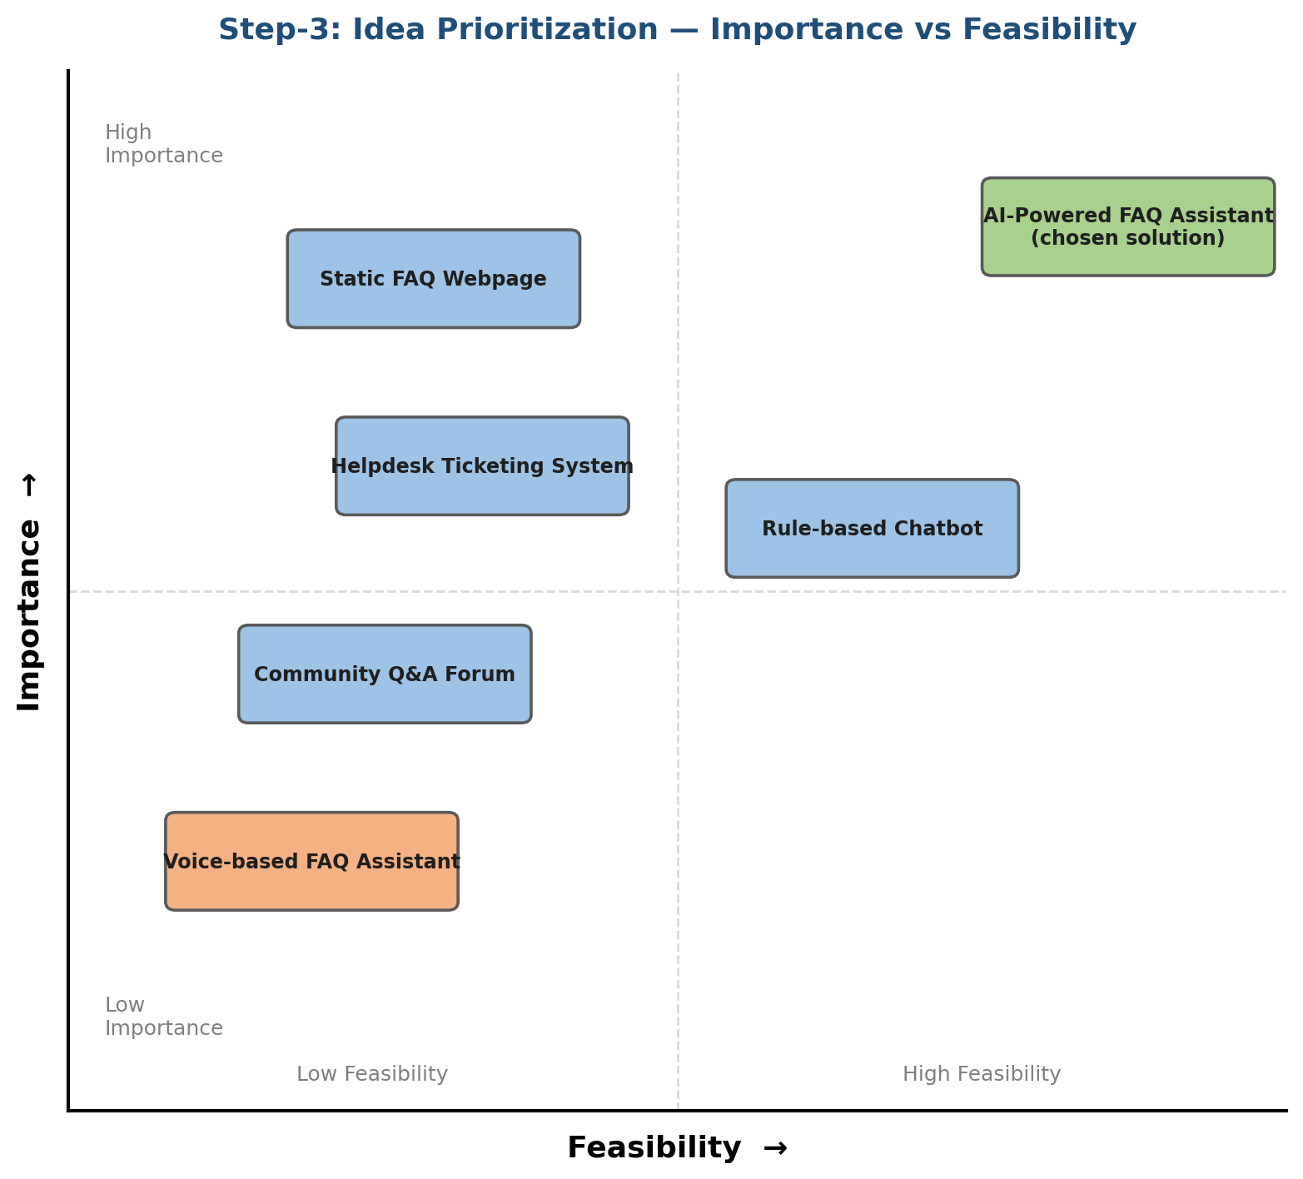
Fig 3.1 — Idea prioritization grid (Importance vs Feasibility)
The “Centralised Knowledge Base” and “AI-Powered Automation” clusters scored highest on both importance and feasibility. The team therefore selected a combined solution — the AI FAQ Assistant — which merges a centralised, categorised FAQ database (MongoDB) with AI-generated answers (Google Gemini) for questions that have no existing match, while “Administration & Insights” and “Access Channels” ideas were noted as future enhancements.

